Jim Ellis cares about the health of our employees and has designed a Wellness Program to help you improve your health when you complete a biometric screening within 60 days of your benefits effective date. Completing the screening process is easy! Just follow the steps below.

- Schedule an appointment with your primary care doctor and take a copy of the attached Biometric Screening Form (sample below).
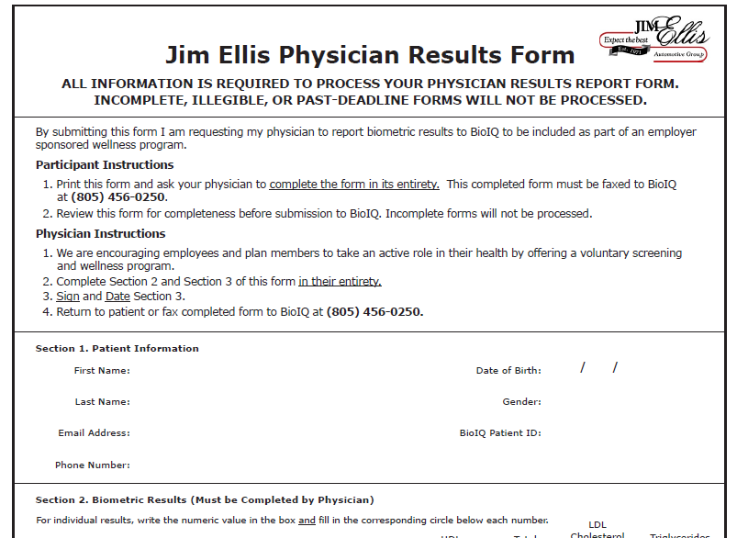

- Once the appointment has been completed, either you or your provider should fax the screening form to (805) 456-0250. The form should also be submitted to Yvonne Teague in HR.

Jim Ellis is committed to helping employees manage your health, and we encourage you to complete these steps as soon as possible. A non-compliance surcharge of $25 per month will apply if the biometric screening is not completed within 60 days of your benefits effective date.
Questions?
Call the Jim Ellis Benefits Service Center at 770-295-1100.
Monday – Thursday from 8am to 6pm and Friday from 8am to 5pm

